Student Performance Prediction System

Project Id: AIML-17

Name : Vanshika Ahuja (Team Leader)
Class Roll Number:74
University Roll Number : 2028900
Section and Group: K G2

Name : Priyanka Rawat (Member2) Class Roll Number:63
University Roll Number :2028807
Section and Group: K G2

- Problem Description................................................................................................ 3
- Architecture ............................................................................................................ 4
- Models model............................................................................................... 5
- Evaluation metrics used .............................................................................. 6
- Preliminary Results and Visualizations ..................................................... 7
- References ...................................................................................................... 8

1. Problem Description
Design and develop an end-to-end machine learning system to predict user movie
preferences based on Netflix user rating history. The project should involve selecting
a
suitable dataset containing user IDs, movie IDs, ratings, and timestamps. Preprocessing should include handling missing values, cleaning duplicate records, normalization of rating values, and transformation of categorical attributes (user/movie IDs encoding). Relevant features such as user viewing behavior, movie popularity, genre, and historical rating patterns should be identified using feature selection techniques. The system should include model training using Logistic Regression, KNN, and SVM classifiers to classify user preference categories (such as Like/Dislike or High
Rating/Low Rating).
The models should be evaluated using classification performance metrics including accuracy, precision, recall, F1-score, confusion matrix, and ROC curve. The project should demonstrate a complete ML pipeline from raw rating dataset to evaluated predictive models.
Expected Output:
1 : High Rating / Recommended
0 : Low Rating / Not Recommended

2.Architecture

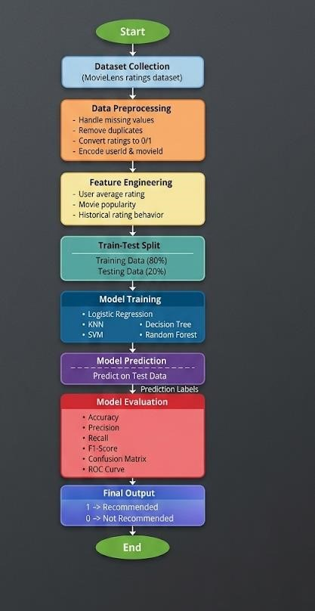

3.Models Used(Applied/ Planned) Give a brief introduction of the models used

1. Logistic Regression
A classification algorithm that predicts the probability of a movie being liked or disliked using a sigmoid function. It is simple, fast, and works well for binary classification problems.

2. K-Nearest Neighbors (KNN)
A non-parametric algorithm that classifies data based on the majority class of its nearest neighbors. It is easy to understand and effective for pattern-based predictions.

3. Support Vector Machine (SVM)
A powerful algorithm that separates data into classes by finding the optimal hyperplane. It is effective in high-dimensional spaces and provides good accuracy.

4. Decision Tree
A tree-based model that makes decisions using a series of if-else conditions. It is easy to interpret and helps in understanding feature importance.

5. Random Forest
An ensemble learning method that combines multiple decision trees to improve accuracy and reduce overfitting. It is robust and widely used in real-world applications.

4.Evaluation metrics used

1. Accuracy
Measures the overall correctness of the model.
It is the ratio of correctly predicted instances to total instances.

2. Precision
Measures how many predicted positive results are actually correct. Useful when false positives are important to minimize.

3. Recall (Sensitivity)
Measures how many actual positive cases are correctly identified. Important when missing positive cases is costly.

4. F1-Score
The harmonic mean of precision and recall.
It provides a balance between precision and recall.

5. Confusion Matrix
A table that shows actual vs predicted values, helping to understand classification performance in detail.

6. ROC Curve (Receiver Operating Characteristic)
A graphical representation showing the trade-off between true positive rate and false positive rate.

5. Preliminary Results and Visualizations

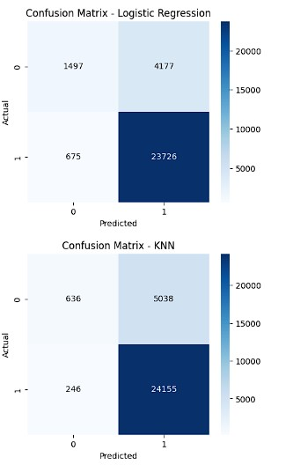

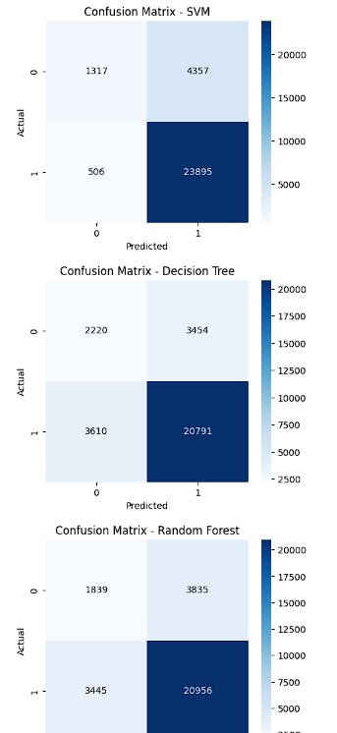

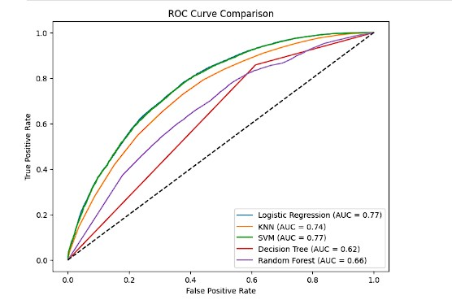
Fig.3
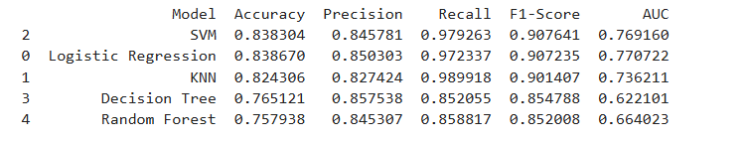

6. References:
Books:
1. Machin Learning with python for everyone – Mark E.Fenner

Online Resources:
- GeeksforGeeks – https://www.geeksforgeeks.org/
- TutorialsPoint – https://www.tutorialspoint.com/cprogramming/index.htm

